Helloworld Web Application Deployment with EC2 Instances.

1. **Deployment Architecture**  
     
   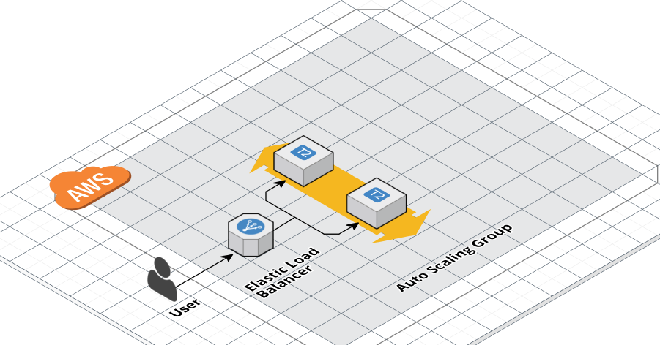
2. **Set up Infrastructure**  
   1. Create SSH Key pair for the creating EC2. We will use the public key to create the EC2 instance and use private key to connect to it for checking.  
   Open power shell and generate SSH key pair with empty passphrase as below.   
   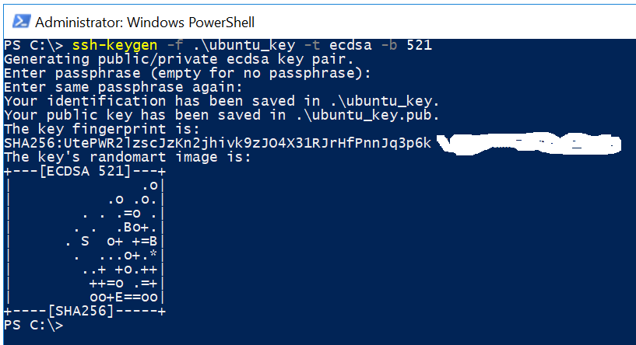  
   2. In order for Terraform to be able to make changes in your AWS account, you will need to set the AWS credentials for the IAM user you created earlier as the environment variables AWS_ACCESS_KEY_ID and AWS_SECRET_ACCESS_KEY in cmd console:  
   set AWS_ACCESS_KEY_ID=(your access key id)  
   set AWS_SECRET_ACCESS_KEY=(your secret access key)  
   3. Create terraform files:   
   - resource.tf : describe resources are created  
   - variables.tf: declaring variables which are used in resources.tf  
   - terraform.tfvars: set value for variable which are declared in the variables.tf  
   - init.sh: init script when the server starts